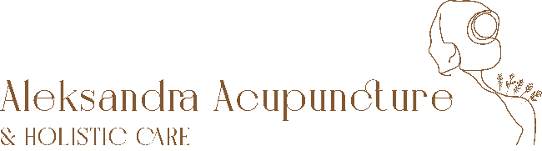

PRIVACY STATEMENT
For a good treatment it is necessary that I, as your treating acupuncturist, prepare a file. This is also a statutory duty imposed by the Medical Treatment Contracts Act (WGBO). Your file contains notes about your state of health and data about the examinations and treatments performed.
Also, what may be included in the file are data that are necessary for your treatment and that, after your explicit consent, I have requested from another care provider, for example from the general practitioner.
At Aleksandra Acupuncture & Holistic Care I do my best to ensure your privacy. This means, among other things, that I:
• handle your personal and medical data carefully,
• ensure that unauthorized persons do not have access to your data (double authentication software).
As your treating acupuncturist, I have sole access to the data in your file.
I have a legal duty of confidentiality (professional secrecy).
The data from your file can also be used for the following purposes:
• To inform other health care providers, for example if the treatment has been completed or if a referral to another therapist has been made. This only happens with your explicit permission.
• For use for observation, during my absence.
• For the anonymized use during peer review.
• A small part of the data from your file is used for the financial administration, so that I, or my administrator can draw up an invoice.
If I want to use your data for another reason, I will first inform you and ask your permission explicitly.
You are free to withdraw consent at any given time.

PRIVATE DATA ON THE INVOICE

The invoice you receive contains the information requested by the health insurer, so that you can declare this bill to your health insurer:
- your name and address
- your date of birth
- your insurance provider and the insurance number
- the date of treatment
- a short description of the treatment, for example '24104 Treatment acupuncture'

RIGHTS REGARDING YOUR DATA

You can request a full disclosure of your data collected by Aleksandra Acupuncture & Holistic Care at any time. You can also ask for your personal data to be modified or deleted. The Dutch medical association states that medical records should be kept for a period of 15 years, after which they must be destroyed. Therefore, if you require for your data to be deleted, Aleksandra Acupuncture & Holistic Care will store it in an inactive archive until the 15 years period expires, then the data will be completely destroyed. Please send me an email at contact@aleksandraacupuncture.nl if you wish to do any of the above.
If you have any further questions about the collection, processing and use of your personal data please contact me directly at contact@aleksandraacupuncture.nl.

DISCIPLINARY REGULATIONS AND COMPLAINTS

The therapist is subject to disciplinary law, which is provided by the KAB (Alternative Treatment Complaints Committee). www.kab-koepel.nl

It is preferable to discuss complaints with the therapist in the first instance. If the client and therapist cannot reach an agreement, the client can also contact the complaints committee of the Zhong: NVTCG Zhong, PO Box 254, 6700 AG Wageningen, telephone: 0317 423 505, info@zhong.nl, www.zhong.nl

CONTACT DETAILS

Aleksandra Boj
Aleksandra Acupuncture & Holistic Care
www.aleksandraacupuncture.nl
contact@aleksandraacupuncture.nl

